# MODULE: 6 (Bootstrap Basic & Advance)

Q-1 . What are the advantages of Bootstrap?

Ans - Open Source — Completely free to download and use.

Easy to use —with the basic working knowledge of HTML, CSS and JavaScript anybody can start development with Bootstrap.

Save lots of time — we can save lots of time and effort using the Bootstrap predefined design templates and classes.

Compatible with browsers — it is compatible with most browsers that are Chrome, Firefox, Internet Explorer, Safari and Opera etc.

Responsive features — Using Bootstrap we can also easily create responsive websites that appear more appropriately on different devices and screen resolutions.

Consistent design — all Bootstrap components share the same design templates and styles through a central library, so the design and layout of our web pages will be consistent.

Q-2 . What is a Bootstrap Container, and how does it work?

Ans- Bootstrap containers are very essential and basic building blocks and bootstrap that wrap a page’s content. It’s responsible for setting and alignment content within it according to viewport or given device. Containers are defined within the container class(.container).

Q-3. What are the default Bootstrap text settings?

Ans - Bootstrap’s default settings bootstrap’s global default font-size is 14px, with a line-height of 1.428. This is applied to the element and all paragraphs ().

Q-4. What do you know about the Bootstrap Grid System?

Ans – Bootstrap grid system – Bootstrap grid system allows up to 12 columns across the page. You can is each of them individually or merge them together for wider columns. You can us all combinations of values summing up to 12. You can use 12 columns each of width 1. Or use 4 columns each of width 3 or any other combination .

[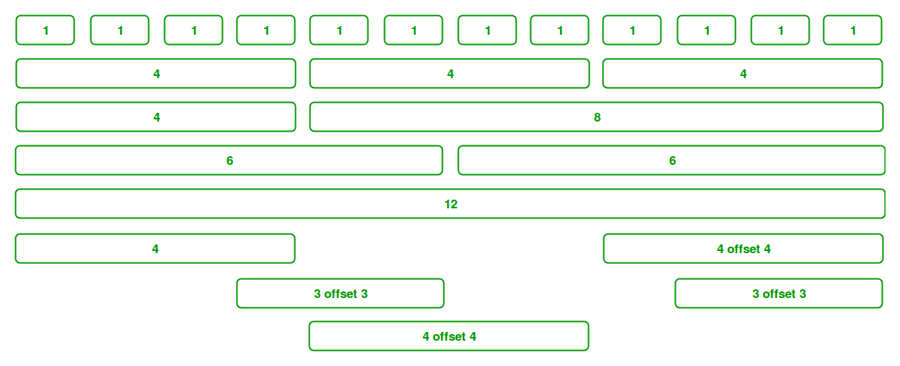](https://media.geeksforgeeks.org/wp-content/uploads/Bootstrap-part-2.png)

Q-5. What is the difference between Bootstrap 4 and Bootstrap 5

## Ans - Bootstrap 4

Grid system - it has 5 tier (XS, SM, MD, LG, XL )

Color- it has limited colors.

JQUERY – it has jquery and all related plugins.

Internet Explorer – Bootstrap 4 supports both IE 10 and 11.

Utilities API – We cannot modify utilities in bootstrap 4.

Gutter – We use .glutter with fontsize in px

## Bootstrap 5

Grid system - it has 6 tier (XS, SM, MD, LG, XL,XXL )

Color- Extra colors added with the looks, A card improved color palette. There are various shades available to choose.

JQUERY – Jquery is removed and switched to vanilla JS with some working plugins.

Internet Explorer – Bootstrap 5 doesn’t support IE 10 and 11.

Utilities API – Bootstrap 5 give freedom to modify and also create our own utility.

Gutter – We use .g* with fontsize in rem.

Q-6 . What is a Button Group, and what is the class for a basic Button Group?

Ans - .btn-group is used for a basic button group. Wrap a series of buttons with class .btn in .btn-group .

<div class = "btn-group">

<button type = "button" class = "btn btn-default">Button1</button>

<button type = "button" class = "btn btn-default">Button2</button>

</div>

Q-7 . How can you use Bootstrap to make thumbnails?

Ans - step 1 – include Bootstrap and JQuery CDN into the <head> tag before all other stylesheet to load our CSS.

Step 2 – Add <div> tag in the HTML body with class row. In that <div> create four div sections to create four images.

Step 3 – Add “col-sm-6” and “col-md-3” to four div section which creates webpage responsive.

Q-8. In bootstrap 4 , what is flexbox ?

Ans - Bootstrap 4 uses flexbox , instead of floats , to handle the layout . The flexible Box layout Module , makes it easier to design flexible responsive layout structure without using float or positioning.

Q-9. How can one create an alert Bootstrap ?

Ans - Alert are available for any text of length of text , as well as optional dismiss button. For proper styling , use one of the eight required contextual classes (e.g. , .alert-succes). For inline dismissal , use the alerts JQuery plugin.

Q-10. What is the bootstrap card and how would you create one ?

Ans - CARD – A card is a flexible and extensible content container. It includes options for headers and footers, a wide variety of content, contextual background colors, and powerful display options.

Example -

